NOTICE OF BOARD WORKSHOP
OF THE ALVIN COMMUNITY COLLEGE DISTRICT
OCTOBER 11, 2021
12:00 P.M.
NOLAN RYAN CENTER

Notice is hereby given that on the 11th day of October 2021, the Board of Regents of the Alvin Community College District will hold a workshop at 12:00 o'clock, p.m., in the Nolan Ryan Center, at Alvin Community College, 3110 Mustang Road, Alvin, Texas.

- Call to order
- Certification of Posting of Notice
- Citizen Inquiries
In accordance with ACC Board Policy BDB (Local), time will be allotted at each regular meeting of the Board of Regents for public comment. Persons who wish to participate in the public comment portion of the meeting must sign up before the meeting begins and must indicate the topic about which they wish to speak. No presentation may exceed five minutes.

Specific factual information or recitation of existing policy may be furnished in response to inquiries, but the Board may not deliberate or decide regarding any subject that is not included on the agenda posted with notice of the meeting.

A person addressing the Board who has a complaint or a concern who has not previously attempted to solve a matter administratively through resolution channels established by policy shall be referred to the appropriate policy to seek resolution.

- Future of Work
- Adjournment

On this 5th day of October 2021, an original copy of this notice was posted on a bulletin board in the administrative offices of the College district at 10:00 o'clock, a.m., on said date.

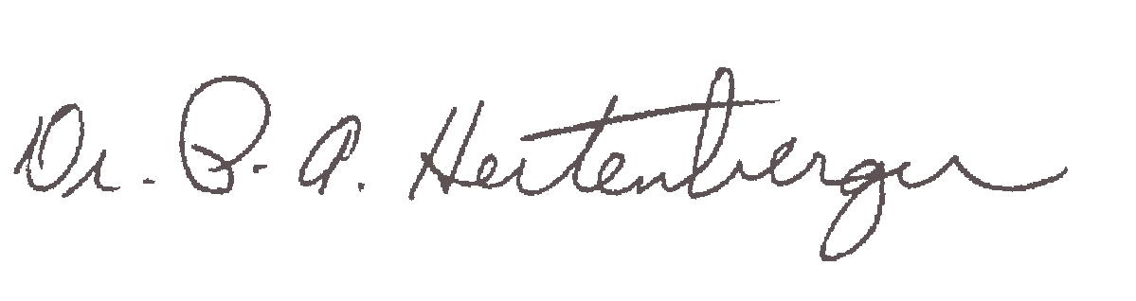

___________________________
Secretary, Board of Regents

